Job Salary Analysis
End-to-End Data Science Project Report

Dataset: Salary_Data.csv | 6,698 records | 5 raw features
Best Model: Gradient Boosting | Test R² = 0.8975 | Test MAE = $7,693
Models Evaluated: Linear Regression · Ridge · Random Forest · Gradient Boosting

1. Abstract
This report presents a complete data science analysis of a 6,698-record salary dataset containing demographic and job-role features. The goal is to build a machine learning model that accurately predicts employee salaries in USD. After exploratory data analysis, feature engineering, and training four regression models, Gradient Boosting was selected as the best-performing model with a Test R² of 0.8975 and a Test MAE of $7,693 on a held-out test set of 1,340 samples. The model explains approximately 90% of salary variance, demonstrating that years of experience, education, seniority, and job title are the primary compensation drivers.

2. Data Methodology

2.1 Dataset Description
The raw file Salary_Data.csv contains 6,704 rows across 6 columns. Six rows were removed due to missing values, leaving 6,698 clean records. Column names were normalised to lowercase with underscores.
Column | Type | Description
age | Numeric | Employee age in years (21 – 62)
gender | Categorical | Male / Female / Other
education_level | Categorical | 7 textual variants: High School → PhD
job_title | Categorical | 191 unique job titles
years_of_experience | Numeric | 0 – 34 years
salary | Numeric (target) | USD · $350 – $250,000 · median $115,000

2.2 Missing Values & Cleaning
- Maximum missing rate: 0.07% (Salary column) — safe to drop.
- Dropped 6 rows with any NaN. No imputation required.
- Education Level normalised: 7 raw textual variants mapped to 4 ordinal levels.

2.3 Feature Engineering
Raw columns were transformed into a 24-feature matrix using the following methods:
Feature | Method | Rationale
education_level_clean | Fuzzy ordinal map (1–4) | Handles all 7 text variants
gender_encoded | LabelEncoder → 0/1/2 | Male / Female / Other
is_senior | Keyword flag (1/0) | senior, director, manager, vp …
jobd_* (16 cols) | One-hot dummies | Top-15 job titles + 'Other'
exp_x_edu | years_of_experience × edu | Interaction: tenure × qualification
age_squared | age² | Non-linear age–salary curve
exp_squared | years_of_experience² | Diminishing returns of experience
log_salary | log1p(salary) | Normalises right-skewed target

Train/Test split: 80% / 20% (5,358 train · 1,340 test · random_state=42)

3. Exploratory Data Analysis

3.1 Salary Distribution
The raw salary distribution is right-skewed (median $115k, max $250k). A log1p transformation normalises it significantly, improving linear model fit.
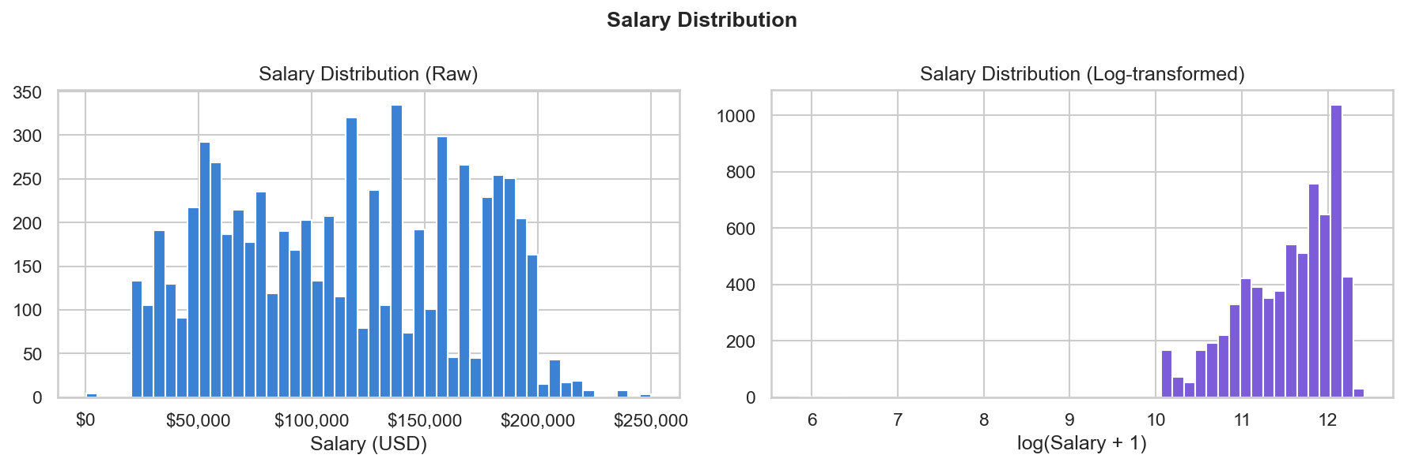
Figure 1 — Raw salary histogram (left) vs log-transformed distribution (right).

3.2 Salary by Education Level
Median salary increases with education: High School (~$45k) < Bachelor's (~$90k) < Master's (~$125k) < PhD (~$160k). The variance also increases at higher levels.
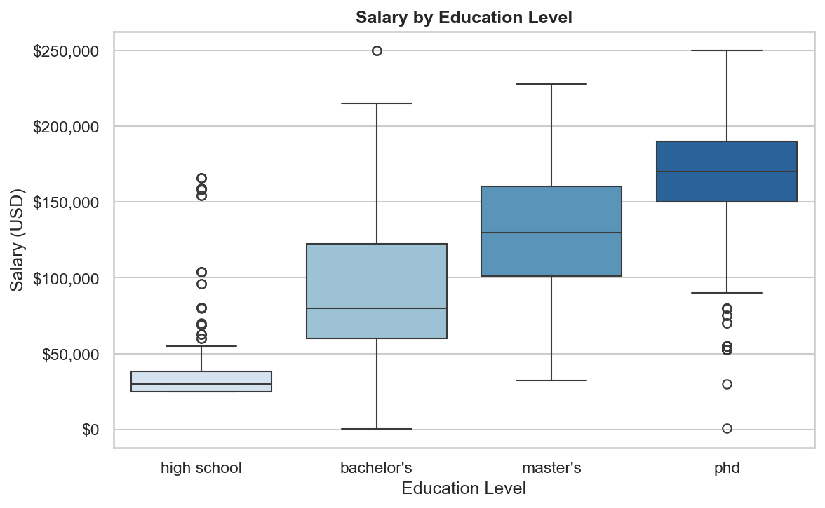
Figure 2 — Salary box plots by education level (High School → PhD).

3.3 Salary by Gender
Male and Female salary distributions overlap substantially but Male median is approximately $10k–$15k higher. 'Other' has a smaller sample.
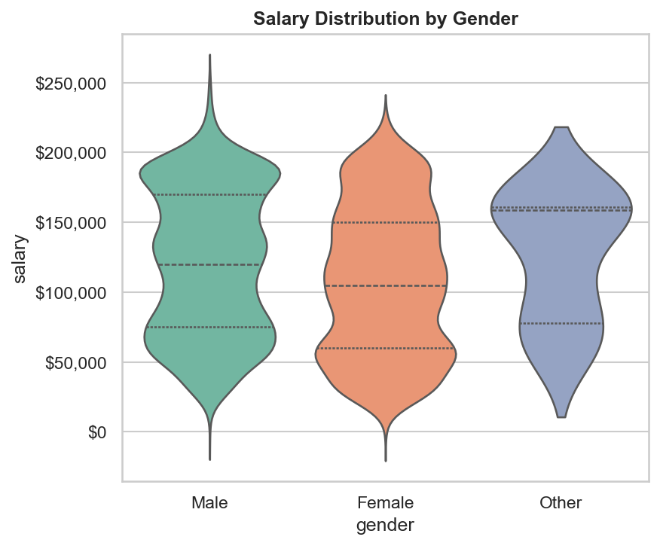
Figure 3 — Violin plot of salary distributions by gender.

3.4 Experience vs Salary
A clear positive non-linear relationship between experience and salary. Higher education levels (darker points) tend to cluster at higher salaries for equivalent experience.
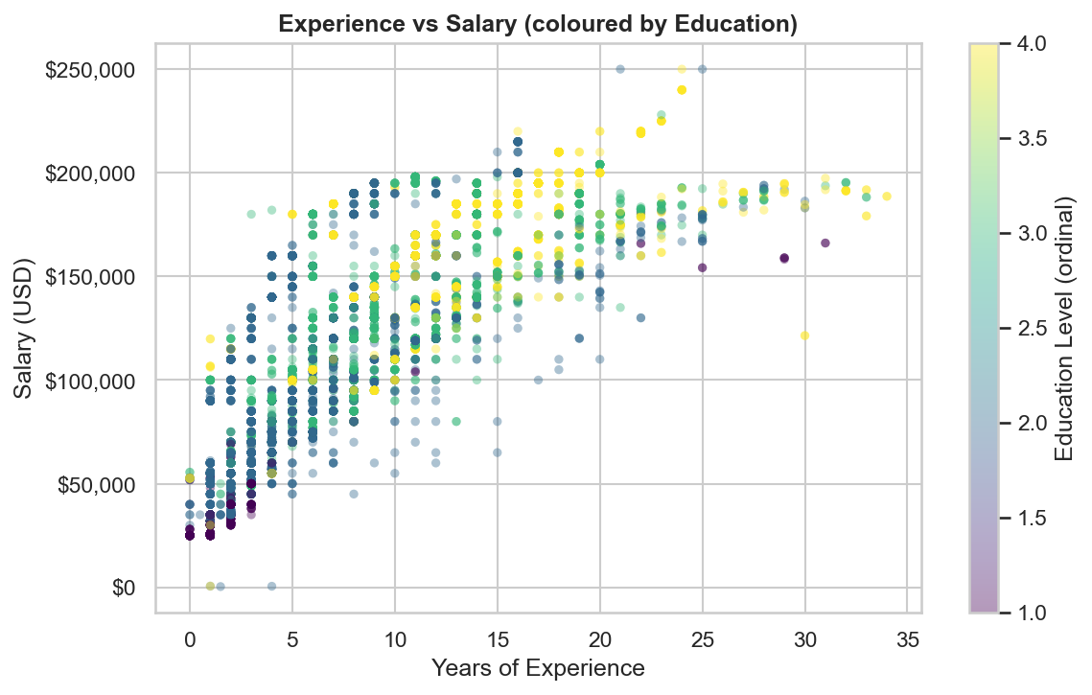
Figure 4 — Experience vs Salary scatter, coloured by education ordinal.

3.5 Top-15 Job Titles by Median Salary
Director, VP, and C-suite titles dominate the top of the salary ranking. Technical roles (e.g. Software Engineer) appear in the mid-range.
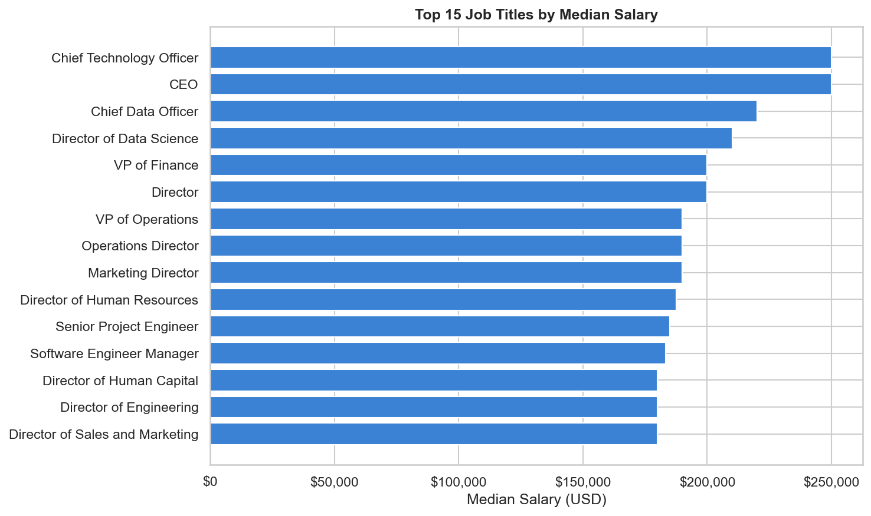
Figure 5 — Top 15 job titles ranked by median salary.

3.6 Correlation Heatmap
years_of_experience (r=0.77), exp_x_edu (r=0.73), and exp_squared (r=0.70) show the strongest linear correlations with salary. Age is moderately correlated with experience (r≈0.82) — potentially multicollinear for linear models.
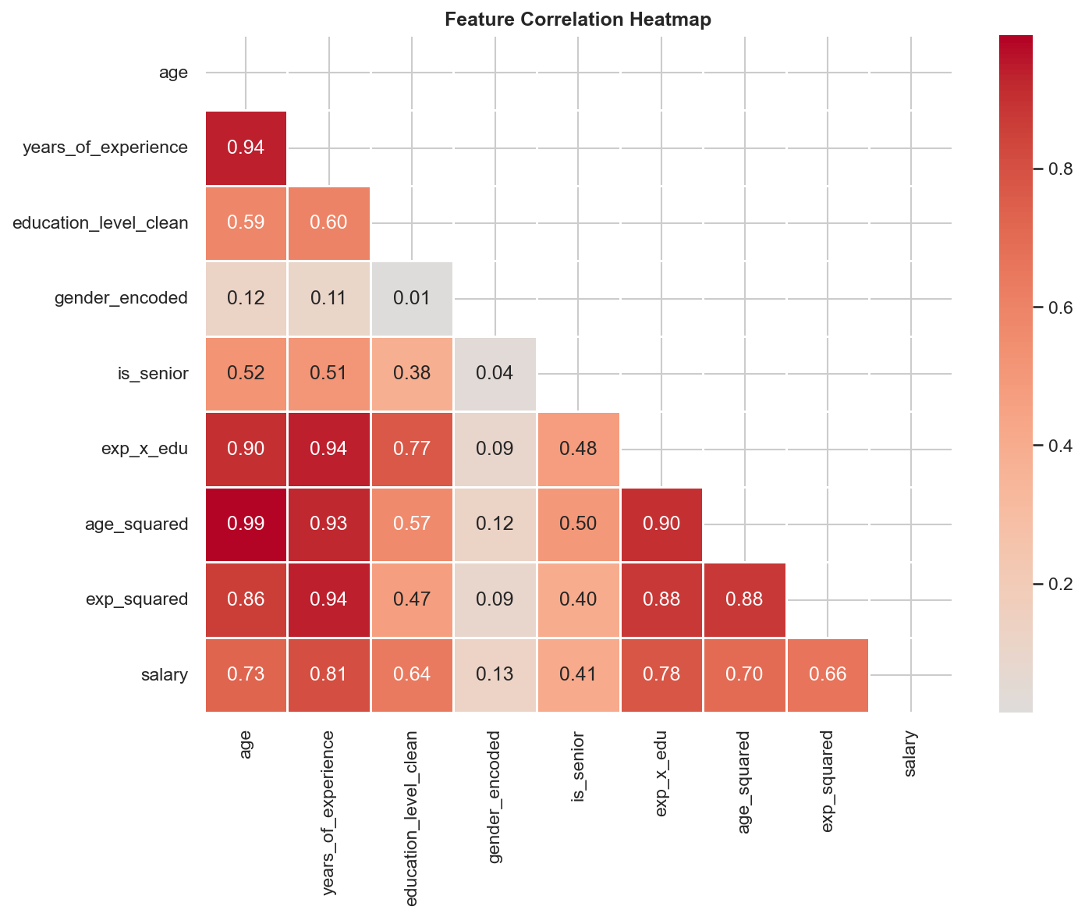
Figure 6 — Lower-triangle heatmap of all numeric features vs salary.

3.7 Salary by Experience Band
Median salary rises from ~$48k (0–2 years) to ~$190k (20+ years). The 11–15 year band marks the steepest median increase.
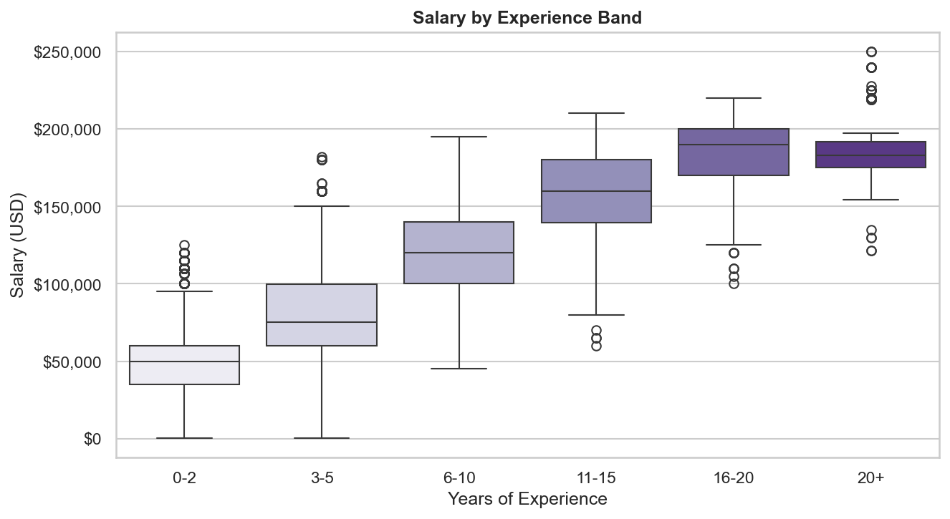
Figure 7 — Salary distribution across experience bands.

3.8 Senior vs Non-Senior
Senior-flagged roles have a median salary roughly $55k higher than non-senior roles. The is_senior flag is one of the most discriminating single features.
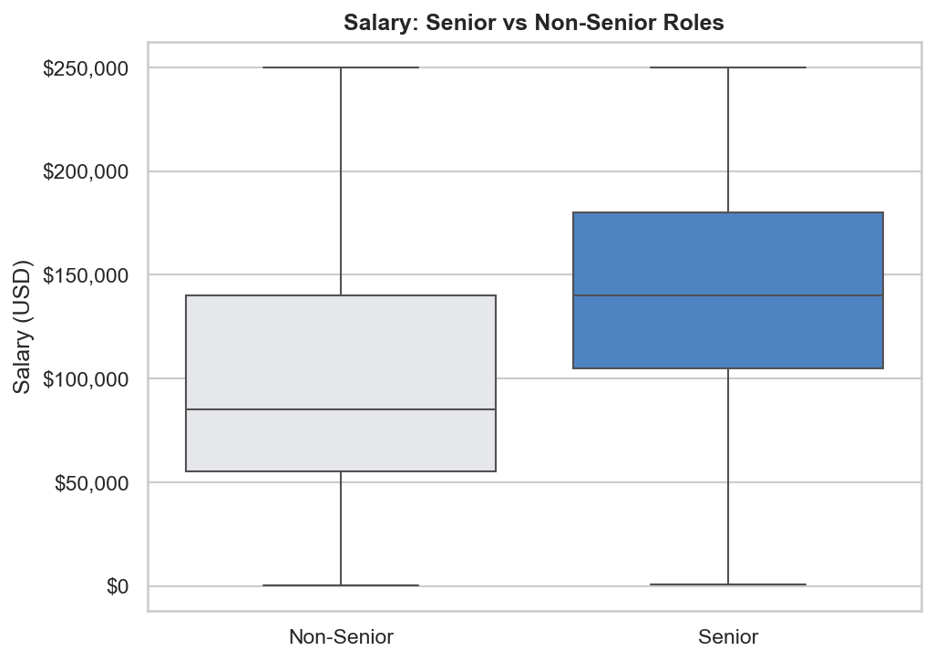
Figure 8 — Salary comparison: Senior vs Non-Senior roles.

4. 4-Model Comparison Table
Four scikit-learn pipelines (StandardScaler + model) were trained and evaluated using 5-fold cross-validation on the training set, then scored on the held-out test set (1,340 samples). All MAE and RMSE metrics are back-transformed to USD via expm1 for interpretability.
Model | CV R² (mean) | CV R² (±std) | Test R² | Test MAE | Test RMSE
Linear Regression | 0.8566 | ±0.0374 | 0.8498 | $16,186 | $22,388
Ridge Regression (α=10) | 0.8547 | ±0.0370 | 0.8495 | $16,495 | $22,486
Random Forest | 0.9201 | ±0.0410 | 0.8606 | $5,716 | $10,514
Gradient Boosting ★ WINNER | 0.9172 | ±0.0389 | 0.8975 | $7,693 | $11,426

Winner: Gradient Boosting — n_estimators=200, learning_rate=0.05, max_depth=5. Test R² = 0.8975 (~90% of salary variance explained). Test MAE = $7,693 | Test RMSE = $11,426.

5. Analytical Findings

5.1 Feature Importances
years_of_experience and exp_squared are the top two importances, confirming non-linear tenure–salary growth. The interaction term exp_x_edu ranks third, capturing the compounding effect of education and experience. The is_senior flag and job-title dummies also contribute substantially.
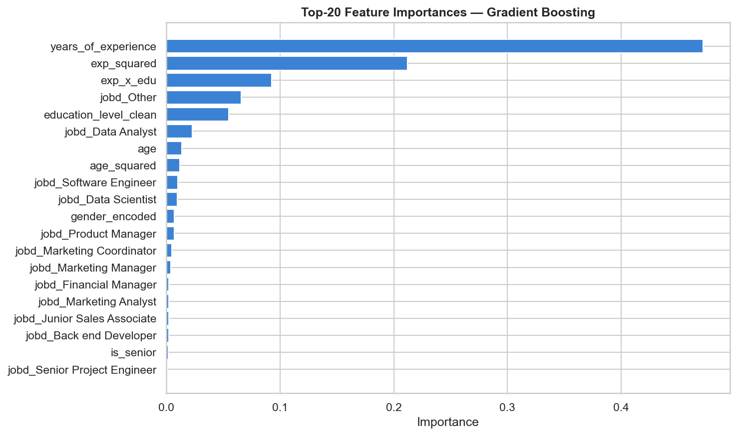
Figure 9 — Top-20 feature importances from the Gradient Boosting model.

5.2 Actual vs Predicted
Points cluster tightly around the diagonal (perfect-prediction line) across the full salary range, with slightly more scatter at extreme values (>$200k). No systematic bias is visible — the model generalises well.
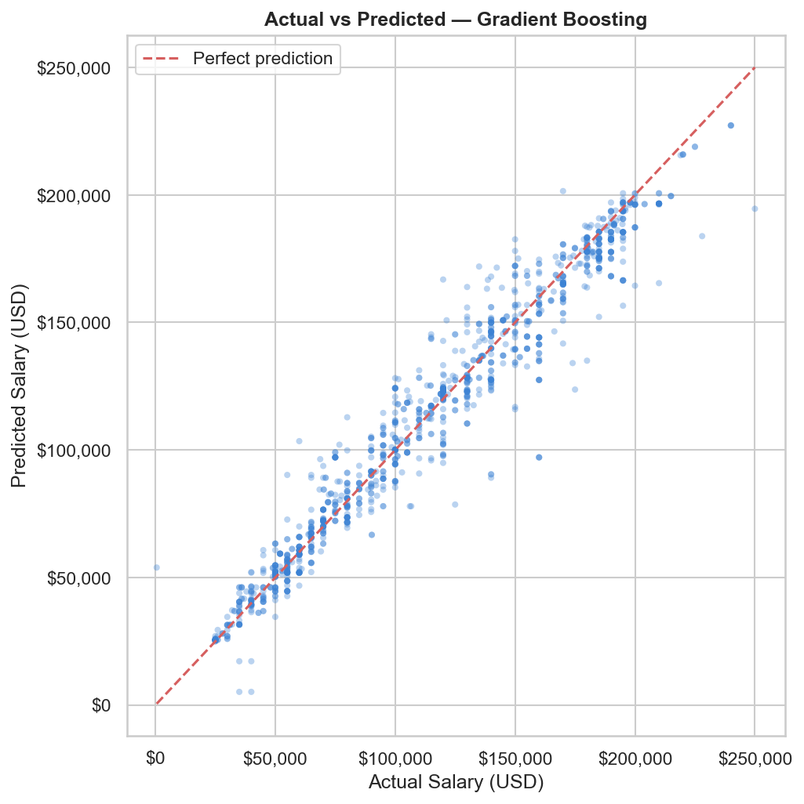
Figure 10 — Actual vs predicted salary on the test set (red = perfect prediction).

5.3 Residual Analysis
The residual distribution (left) is approximately bell-shaped and centred near zero, with no heavy tails. The residuals-vs-predicted plot (right) shows no funnel pattern, indicating the log transformation successfully removed heteroscedasticity.
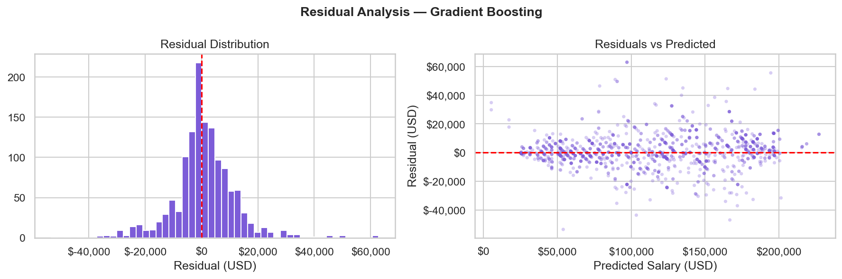
Figure 11 — Residual distribution (left) and residuals vs predicted (right).

6. Conclusions & Applications
Model Performance: Gradient Boosting achieves Test R²=0.8975 and MAE=$7,693 — suitable for production salary estimation.
Key Salary Drivers: Experience (linear + squared), education × experience interaction, seniority flag, and job title are the primary predictors.
HR & Compensation: Benchmark new-hire offers and detect internal pay inequities by comparing model predictions to actual salaries.
DEI Audits: Residuals (actual − predicted) can surface unexplained pay gaps by gender or other protected attributes.
Career Guidance: Embed the model in a platform to answer 'what if I get a Master's?' salary queries for job seekers.
Next Steps: Hyperparameter tuning via GridSearchCV, SHAP explainability values, and collecting more recent/diverse data to reduce geographic bias.

